23.52: From Problem 22.51, the electric field of a sphere with radius R and q distributed uniformly over its volume is 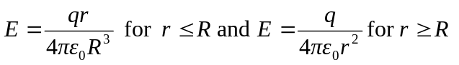
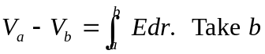at infinity and 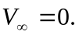 Let point a be a distance 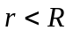from the center of the sphere.
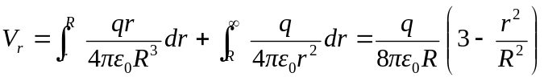
Set 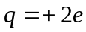 to get 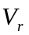for the sphere. The work done by the attractive force of the sphere when one electron is removed from 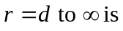
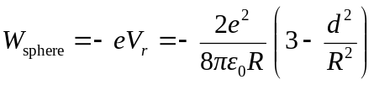
The total work done by the attractive force of the sphere when both electrons are removed is twice this, 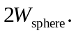 The work done by the repulsive force of the two electrons is 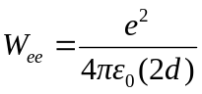 The total work done by the electrical forces is 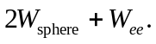 The energy required to remove the two electrons is the negative of this,
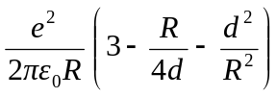
We can check this result in the special case of d = R, when the electrons initially sit on the surface of the sphere. The potential due to the sphere is the same as for a point charge 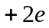 at the center of the sphere.

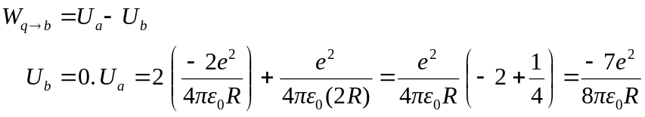

The work done by the electric forces when the electrons are removed is 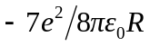and the energy required to remove them is 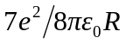. Setting d =R in our general expression yields this same result.

